Abstract— This project deals with the design and implementation of a series-shunt feedback amplifier shown in figure I. The solutions from problem 8.28 were used in this design; specifically, the values of I_{C1}, I_{C2}, I_{C3}, R_{C1}, R_{C2}, R_{E}, R_{F} and h_{fe.} The value of V_{cc} was selected to be 10V. From these values a DC biasing circuit for Q1 and Q2 and a practical current source for Q3 biasing were designed. Capacitors were added to the final circuit in the same way as examples 8.7 and 8.8 shows. After the final circuit was designed Pspice was used to simulate the circuit for Af, Rif, Rof, and closed loop gain. Then given that the low frequency open loop poles are 10 and 10^2 Hz, the value of β for which the two poles coincide was calculated. Also, the value of β for which the closed loop gain will be stable given that the open loop gain is 10^5 and the high frequency poles are at 10^5, 3.16x10^5 and 10^6 Hz. The results are then discussed and compared to the simulation results.
Series-Shunt Feedback Control
Tan Nguyen, tannguyen_79@yahoo.com
Trang Pham, Anna_V21@yahoo.com
Eudora Gunarta, egunarta@umd.umich.edu

I. introduction
Why negative feedback? Most physical systems incorporate some form of feedback from electronics circuits to the modeling of biological systems. Feedback can be either negative or positive. In amplifier design, negative feedback is applied to effect one or more of the following properties:
- Desensitize the gain to make the gain less sensitive to variations in the value of circuit components.
- Reduce nonlinear distortion to make the gain constant, independent of signal level.
- Reduce the effect of noise.
- Control the input and output impedances.
- Extend the bandwidth of the amplifier.

The general feedback structure:
Figure (a) shows the basic structure of a feedback amplifier. The x quantities can represent either a voltage or current signal.

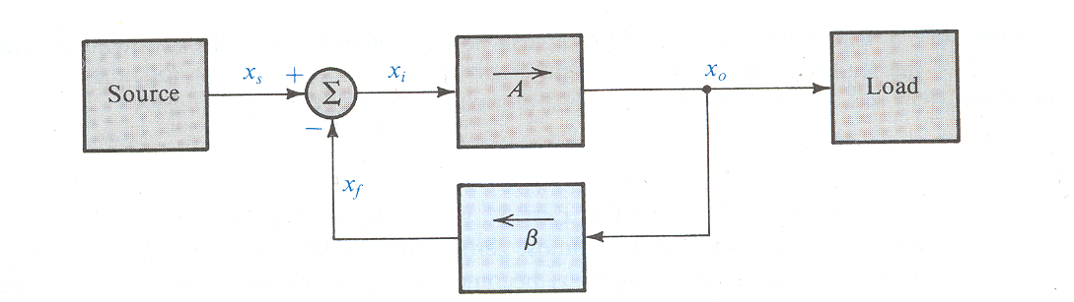
Figure a

The output Xo is related to the input Xi by the equation
$$X_{o}={\text{Ax}}_{i}$$
where A is the open-loop gain.

The signal with feedback Xf is related to the feedback factor β by
$$x_{f}={βx}_{o}$$
The feedback signal Xf is related to the source Xs and the input signal by the equation
$$x_{i}=x_{s}−x_{f}$$

The gain of the feedback amplifier is given by,

$$A_{f}≡\frac{\text{Vo}}{\text{Vs}}=\frac{A}{1+Aβ}$$

What is series-shunt and why use series-shunt?
Series-shunt is one of the four basic feedback topologies. This type of feedback is used for voltage amplifiers. This topology not only stabilizes the voltage gain but also results in a higher input resistance and a lower output resistance, which are desirable properties for a voltage amplifier.

Ideal situation:
The ideal structure of the series-shunt feedback amplifier is shown in figure below. It consists of a unilateral open-loop amplifier (A circuit) and an ideal voltage-sampling series-mixing feedback network (β circuit).

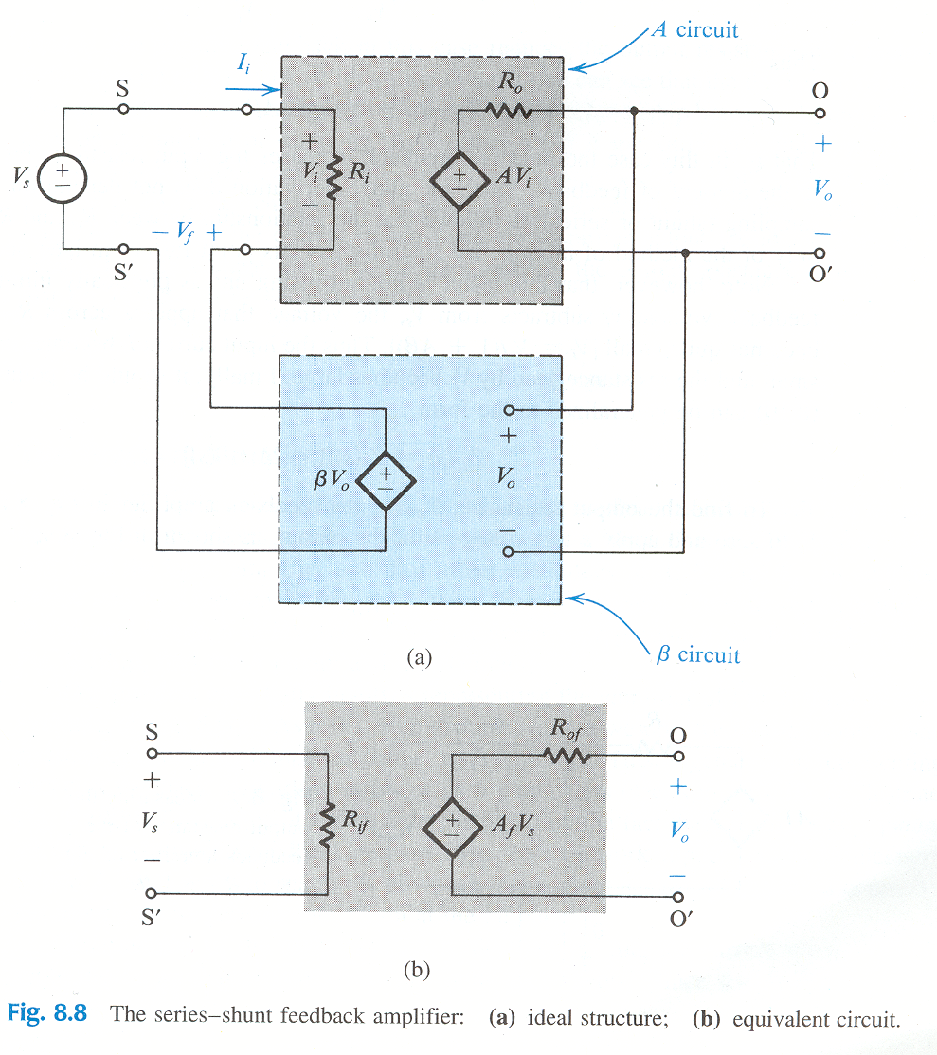

The closed loop voltage gain is given by,
$$A_{f}≡\frac{\text{Vo}}{\text{Vs}}=\frac{A}{1+Aβ}$$

and input and output resistances is given by,

$$\begin{aligned}R_{\text{if}}=R_{i}(1+Aβ) \\ R_{\text{of}}=\frac{R_{o}}{1+Aβ}\end{aligned}$$

Practical situation:

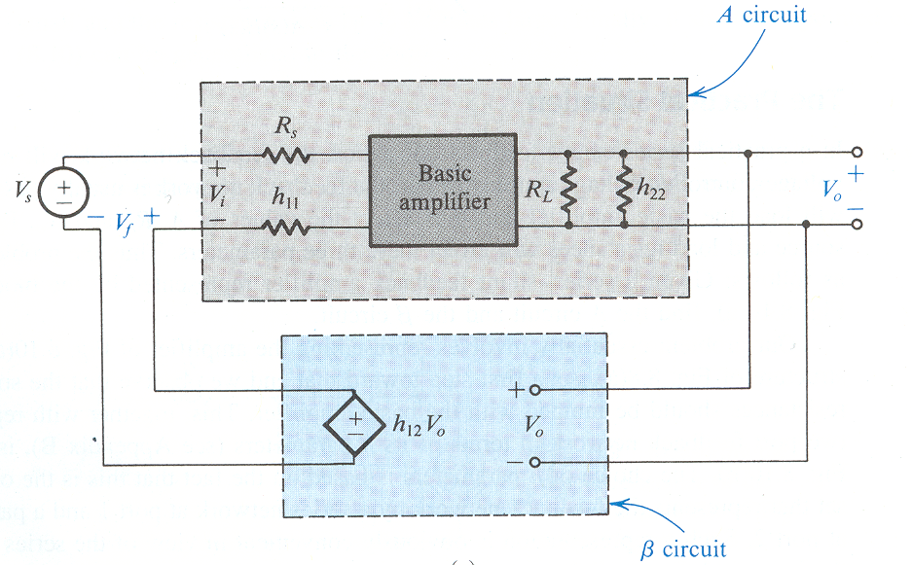

In a practical series-shunt feedback amplifier, the network will not be an ideal voltage-controlled voltage source. Rather, the feedback network is usually passive and hence will load the basic amplifier and thus effect the values of A, Ri and Ro. Now Ri and Ro become:

$$\begin{aligned}R_{\text{in}}=R_{\text{if}}+R_{s} \\ R_{\text{out}}=\frac{1}{\left(\frac{1}{R_{\text{of}}}−\frac{1}{R_{L}}\right)}\end{aligned}$$

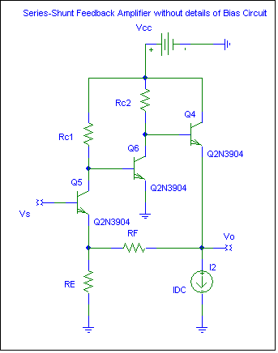
Figure I: Series-Shunt Feedback Amplifier

II. SPECIFICATION OF DESIGN

The design of this amplifier circuit was done based on the following requirements:

A DC biasing circuit for Q1 and Q2, and a practical current source for Q3 biasing and add proper capacitors to the design circuit.

(a) Calculate and (b) simulate the circuit for Af, Rif, Rof, and open loop gain.

Find at what β will the two closed loop poles become coincide, assuming β is frequency independent, where the low frequency open loop poles has been determined at 10 and 10² Hz.

Find β that the corresponding closed loop will be stable, assuming β is frequency independent, where the open loop gain of 10⁵, and high frequency poles are at 10⁵, 3.16x10⁵, and 10⁶ Hz.

III. THEORETICAL IMPLEMENTATION

- The following A circuit is a combination of a DC biasing circuit for Q1 and Q2, a practical current source for Q3 biasing, and proper capacitors.

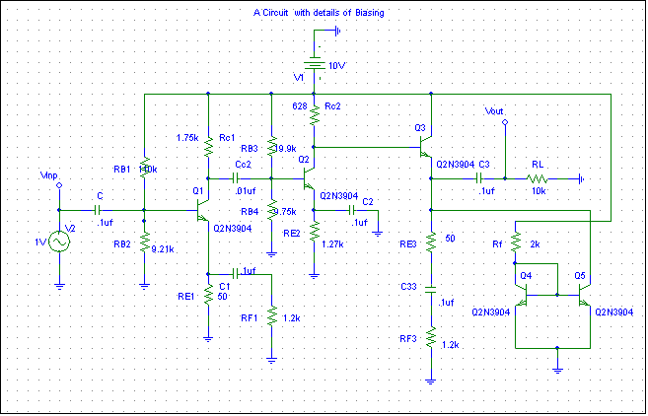
Figure II: A circuit with details of Biasing (see attachment for more details)

We were able to design the A circuit based on the following given parameters: I_{C1}=1mA, I_{C2}=2mA, I_{C3}=5mA., R_{C1}= 1.75k$Ω$, R_{C2}=628k$Ω$, R_{E}=50$Ω$, R_{F}=1.2k$Ω$, h_{fe}=B =100 and selected voltage of V_{cc}=10V. For other parameters that shown in the A circuit were chosen to met the requirement.

(a) Parameter Calculation of Af, Rif, Rof, and open loop gain:

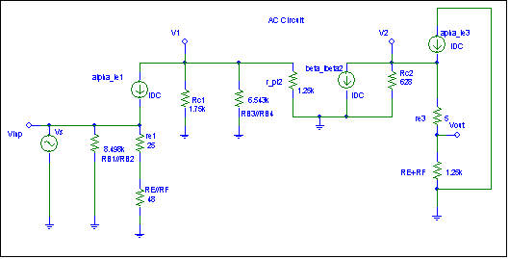

Figure III: AC Circuit Model

To calculate the feedback gain (Af), the input resistance with feedback (Rif), the feedback output resistance (Rof) and the open loop gain of the circuit, we have the circuit with its AC model as shown above.
First, obtaining r_{e1}, r_{e2}, r_{e3}, and r${}_{π2}$ by the following with:
r_{e1} $=\frac{V_{t}}{I_{E}}=α\frac{V_{t}}{I_{c}}=\frac{\text{25}\text{mV}}{1\text{mA}}=\text{25}Ω$
r_{e2}$=\frac{\text{25}\text{mV}}{2\text{mA}}=\text{12}\text{.}5Ω$
r_{e3}$=\frac{\text{25}\text{mV}}{5\text{mA}}=5Ω$
r${}_{π2}$$=(β+1)r_{e2}=\text{101}(\text{12}\text{.}5)=1\text{.}\text{25}kΩ$

At the collector of Q1, Vi is the output voltage of the first stage. The resistors connected to Vi form a current divider

$A_{1}=\frac{\text{Vi}}{V_{s}}=α\frac{i_{e}(R_{C1}||r_{π2}||R_{B3}||R_{B4}}{V_{S}},$$i_{e}=\frac{V_{S}}{(r_{e1}+R_{E}||R_{F})||R_{B1}||R_{B2}}$
$A_{1}=−α\frac{R_{C2}||r_{π2}||R_{B3}||R_{B4}}{(r_{e1}+R_{E}||R_{F})||R_{B1}||R_{B2}},$$\text{where}→α=−\frac{β}{(β+1)}≈−1,$$β=\text{100}=h_{\text{fe}}$

$$A_{1}=−9V/V$$

Now calculate the gain for second the second stage. By inspection the feedback network is in parallel with the collector of Q2. There is an internal resistance r_{e2} of Q2, which formed a voltage divider.

$$A_{2}=\frac{V_{2}}{V_{1}}=−\frac{R_{C2}||(β+1)(r_{π3}+R_{E}+R_{F})}{r_{e2}}=−\text{50}V/V$$

Since the third stage is non-inverting amplifier, so the output is at the emitter.
So using the following equation can solve A3:

$$A_{3}=−α\frac{R_{E}+R_{F}}{(r_{e3}+R_{E}+R_{F})}=0\text{.}\text{961}V/V$$

Therefore, the open-loop gain is the combination of A₁ multiply by A₂ & A₃

A=A₁ *A₂ * A₃=432

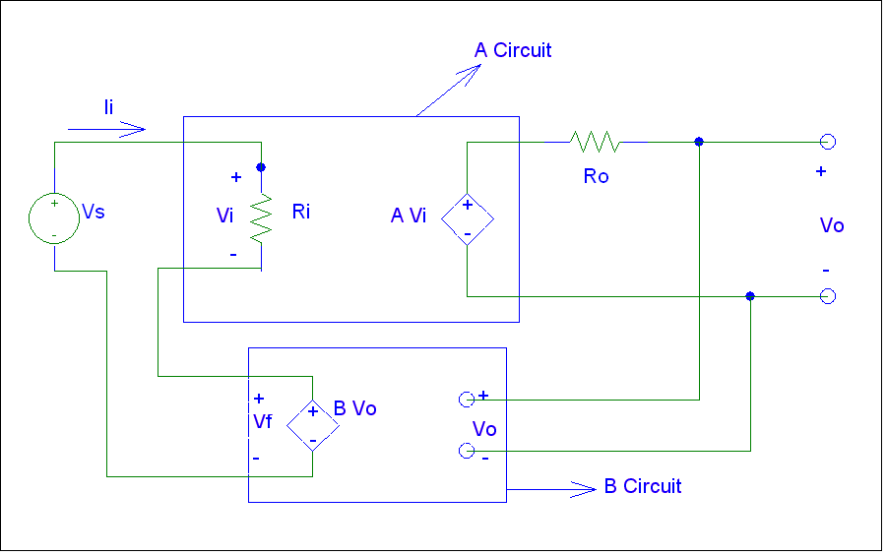
Figure IV: A and B circuit

The circuit above exactly follows the ideal feedback model of general structure the feedback amplifier in the text book. Therefore, the close-loop voltage gain A_{f} is given by
A_{F}=$\frac{\text{Vo}}{\text{Vs}}$=-$\frac{A}{1+βA}$, where β=$\frac{R_{E}}{R_{E}+R_{F}}$= 0.04
Calculate the above equation, the feedback gain =23.6V/V

The input resistance R_{i} is the resistance seen by the input voltage source V_{s}. The value of R_{i} can be found from the circuit A as follows:

R_{i}=R_{B1}||R_{B2}||[(B+1)r_{e1} +R_{E}||R_{F}]=1.975k$Ω$

Therefore, the feedback input resistance can be determined as follows:
R_{if}=R_{i}*(1+BA)=36.103k$Ω$
To find the output resistance R_{o} of the A circuit we can break the circuit between the emitter of Q3 and the collector of Q3. The resistance looking between these two nodes can be found to be.

R_{o}= (R_{E}+R_{F})||(r_{e3} +$\frac{R_{C2}}{β+1}$) = 11.11$Ω$
Thus, the feedback output resistance can be determined as follows:
$$R_{\text{of}}=R_{o}∗\frac{1}{1+βA}=0\text{.}\text{6077}Ω$$

2) (b) Simulation and Verification of Af, Rif, Rof, and open loop gain:

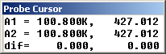
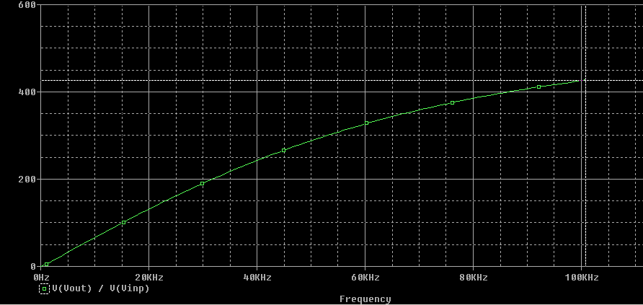
Figure V: Verification of overall open-loop gain (A)
As we simulate the circuit for Open-loop gain (A), we have the above graph. From the Probe cursor results, we get the overall open gain is 427V/V which is very close to the calculate results (432). So, the open-loop gain is verified by simulation.

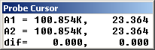
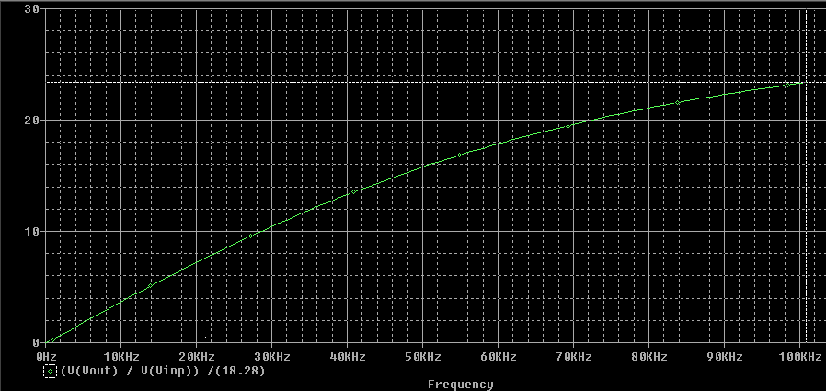
Figure VI: Verification of (A_{f}) feedback gain
As we simulate the circuit for feedback gain (Af), we have the above graph. From the Probe cursor results, we get the feedback gain is 23.3V/V which is very close to the calculate results (23.6). So, the feedback gain is verified by simulation.

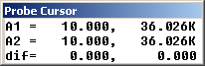
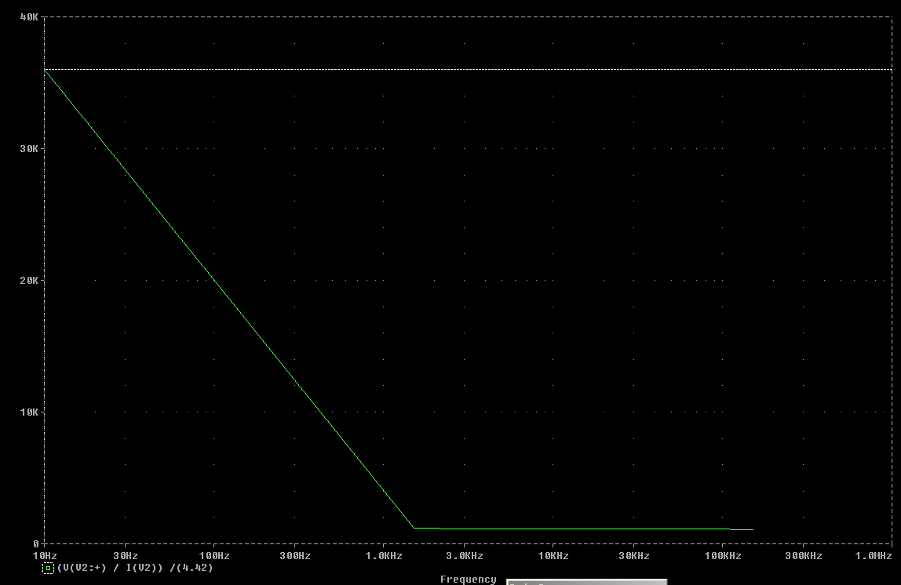
Figure VII: Verification of feedback input resistance ( R_{if)}
As we simulate the circuit for feedback input resistance (Rif), we have the above graph. From the Probe cursor results, we get the feedback input resistance is 36.026kΩ, which is very close to the calculated results (36.103kΩ). So, the feedback input resistance is verified by simulation.

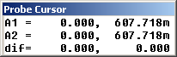
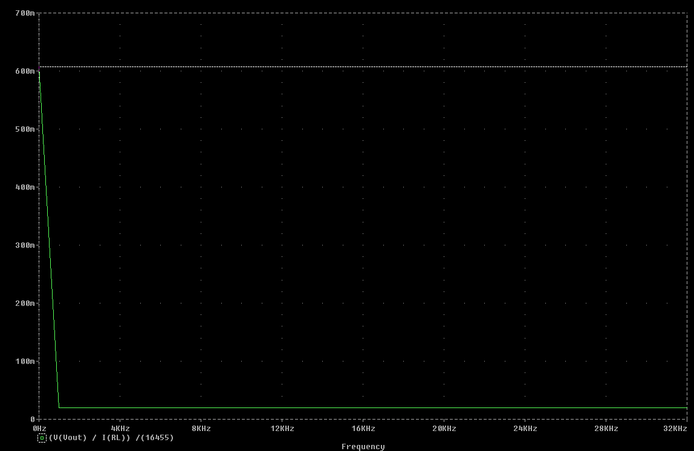
Figure VIII: Verification of feedback output resistance (R_{of)}
As we simulate the circuit for feedback output resistance (Rof), we have the above graph. From the Probe cursor results, we get the feedback input resistance is 0.607Ω, which is very close to the calculated results (0.6077Ω). So, the feedback output resistance is verified by simulation.

- Find at what β will the two closed loop poles become coincide, assuming β is frequency independent, where the low frequency open loop poles has been determined at 10 and 10² Hz.

By using the following open-loop transfer function we will find the value of β at which the two poles become coincident:
. $A(s)=\frac{A_{O}}{[1+(S/{ω_{p1}})][1+(S/{ω_{p2}})]}$
Since the open loop poles has been determined at 10 and 10² Hz.
Thus, the open-loop transfer function is characterized by these two real-axis poles:
where Ao=427V/V is the overall gain that we get it from the simulation:
$$A(s)=\frac{A_{o}}{[1+(S/{\text{10}})][1+(S/{{\text{10}}^{2}})]}$$
in these case, the close-loop poles are obtained from 1+A(s)β=0, which leads to
$$S^{2}+S({ωp}_{1}+{ωp}_{2})+(1+A_{o}β){ωp}_{1}{ωp}_{2}=0$$
where ${ωp}_{1}=\text{10},{ωp}_{2}={\text{10}}^{2}$
Then $S^{2}+S(\text{10}+{\text{10}}^{2})+(1+A_{o}β){ωp}_{1}{ωp}_{2}=0$
Thus the closed-loop poles are given by
$$S=−0\text{.}5({ωp}_{1}+{ωp}_{2})±0\text{.}5\sqrt{({ωp}_{1}+{ωp}_{2})^{2}−4(1−A_{0}β){ωp}_{1}{ωp}_{2}}$$
From this equation we see that as the loop gain A_{o}β is increased from zero, the poles are brought closer together. Then a value of loop gain is reach at which the two poles become coincident. If the loop gain is further increased, the two poles become complex conjugate and move along a vertical line.
Therefore,
$$S=−0\text{.}5({ωp}_{1}+{ωp}_{2})±0\text{.}5\sqrt{({ωp}_{1}+{ωp}_{2})^{2}−4(1−A_{0}β){ωp}_{1}{ωp}_{2}}$$
where A_{o} is the over all gain we got it from the simulation A_{o}$\text{427}V/V$
Since as the loop gain A_{o}β is increased from zero we can set the right hand side of the S equation equal to zero to solve for β in order to have the two poles become coincident.
$\sqrt{({ωp}_{1}+{ωp}_{2})^{2}−4(1−A_{0}β){ωp}_{1}{ωp}_{2}}$= 0
$\sqrt{({\text{110}}^{2})−4(1+\text{427}β)\text{110}}$=0
Solve for β=0.062
Therefore, when β=0.062 the two closed loop poles will become coincident.

- Find β that the corresponding closed loop will be stable, assuming β is frequency independent, where the open loop gain of 10⁵, and high frequency poles are at 10⁵, 3.16x10⁵, and 10⁶ Hz.

By using the following high frequency transfer function we have:
$$A_{H}(s)=\frac{{\text{10}}^{5}}{[1+(S/{{\text{10}}^{5}})][1+(S/3\text{.}\text{16}E5)][1+(S/{{\text{10}}^{6}})]}$$

To find an approximate $β$that the system would be stable, a chosen frequency value between 3.16E5 ~ 10⁶ which is
f=6.6x10⁵ Hz
then substitute the chose frequency of 6.6x10⁵ into A_{H}(s) we get the following:
$\begin{aligned}|A|=\frac{{\text{10}}^{5}}{\sqrt{1+(6\text{.}{6E5}/{{\text{10}}^{5}})^{2}}\sqrt{1+(6\text{.}{6E5}/3\text{.}\text{16}E5)^{2}}\sqrt{1+(6\text{.}{6E5}/{{\text{10}}^{6}})^{2}}} \\ |A|=\text{5399}\end{aligned}$$β\frac{{\text{10}}^{5}}{\sqrt{1+(6\text{.}{6E5}/{{\text{10}}^{5}})^{2}}\sqrt{1+(6\text{.}{6E5}/3\text{.}\text{16}E5)^{2}}\sqrt{1+(6\text{.}{6E5}/{{\text{10}}^{6}})^{2}}}≤1$$β≤0\text{.}\text{000185}$
Since β is frequency independent so we will not taking ω (omega) into account.
Therefore, the system will be stable at $β≤1\text{.}\text{85}E−4$

DISCUSSION OF PSPICE &
THEORETICAL ANALYIS

The major point of using DC biasing is that the parallel combination of two parts of voltage divider (its AC resistance since DC supply looks like ground when we solved with superposition) must by at least 10x less than βR_{E.} Then we can largely ignore Zin of the follower since it will not contribute much to the parallel combined resistance.
We used the current mirror instead of a constant current source. The special connection of Q4 and Q5 provides an output current Io that is related to the reference current I_{REF} by the ratio of the aspect ratios of the transistors; that is, the relationship between Io and I_{REF} is solely determined by the geometry of the transistors. In the special case of identical transistors, Io= I_{REF} , and the circuit simply replicates or mirrors the reference current in the output terminal.

For the 1st task, we were able to design the A circuit for Q1 and Q2 based on the parameters given (I_{C1}, I_{C2}, I_{C3}, R_{C1}, R_{C2}, R_{E}, R_{F} and h_{fe}) and a selected value of Vcc=10V.

For task 3, the equivalent AC circuit was drawn also the A and β circuits. Then the values of Rif and Rof were calculated to be 36.103kΩ and 0.6077kΩ respectively. Indeed, the design does meet the requirement of high input resistance and low output resistance. After the simulation was done, the results are that the closed-loop gain AF=23.6V/V which is very close to the theoretical calculation AF=23.3V/V.

For task 4, it was found that for β=0.059 the two low frequency open loop poles, 10Hz and 10^2Hz, coincide.

For task 5, the approximate value of β for which the system would be stable is β<=0.000185. So, as long as β is maintained in this range this system will always be stable; meaning that the frequency at which |Aβ|=1, the phase angle is less than 180º (in this case the frequency was chosen to be 6.6x10^5Hz).

Thus, the design shows satisfactory results and fulfills the requirements specified before.

CONCLUSION
Through the series-shunt feedback amplifier designed, we have learned that the series-shunt is an amplifier with negative feedback which gain is stable and its high input resistance and low output resistance. During the design process we also learned how to construct the A and the β circuit and calculated the closed loop gain. This design, gives us a deeper understand of signal process analysis.
APPENDIXES:
A) Theoretical A Circuit Diagram
B) Theoretical A & B Circuit Digram
C) Simulation results of Af, Rif, Rof, and open loop gain

REFERENCES:
[1] Micro-electronics circuits/ Adel S. Sedra, Kenneth C. Smith. – 4 th ed., New York Oxford, 1998

APPENDIX A:

APPENDIX B:

APPENDIX C:



 

